**Specification: Holidaze App**

My application is called Holidaze. Its purpose is for personal use and allows the user to plan out a return plane trip and receive information regarding the cost of the flights involved. The application will generate a list of flights, with the cheapest at the top as given by the API. This will be done by utilizing travelpayouts’ API (<https://rapidapi.com/Travelpayouts/api/flight-data/>).

The user will also have the ability to save certain search parameters within separate folders for later use, for example “beach holidays” or “city breaks”, so that the user can retrigger the search without the effort of typing everything in again.

The user will be able to name and save their custom folders on their personal account on the app, so that they can easily access them the next time they use the application.

Furthermore, the user can save their own bucket list of destinations.

My aim is to make it simple to use and navigate the app, and to fulfil this aim, I will be implementing features such as touch gestures. Finally, to assist the user in properly interacting with the application and make full use of its functionality, a user guide screen will be a part of this application.

The user will be able to modify the app’s settings, such as their default base airport and their preferred colour scheme.

**UI Sketches**

**Screen Layout**

Figure - Screen Layout

A screen is reachable directly from the screen to the left of it in Figure 1.

**Screens**

**Login**

1: Screen title

2: App logo

3: Enter username

4: Enter password

5: Clears username and password text

6: Initiates login process – if successful, takes user to homepage

7: Toast that pops up when a wrong username-password combination is entered

**Homepage**

Figure - Login Screen

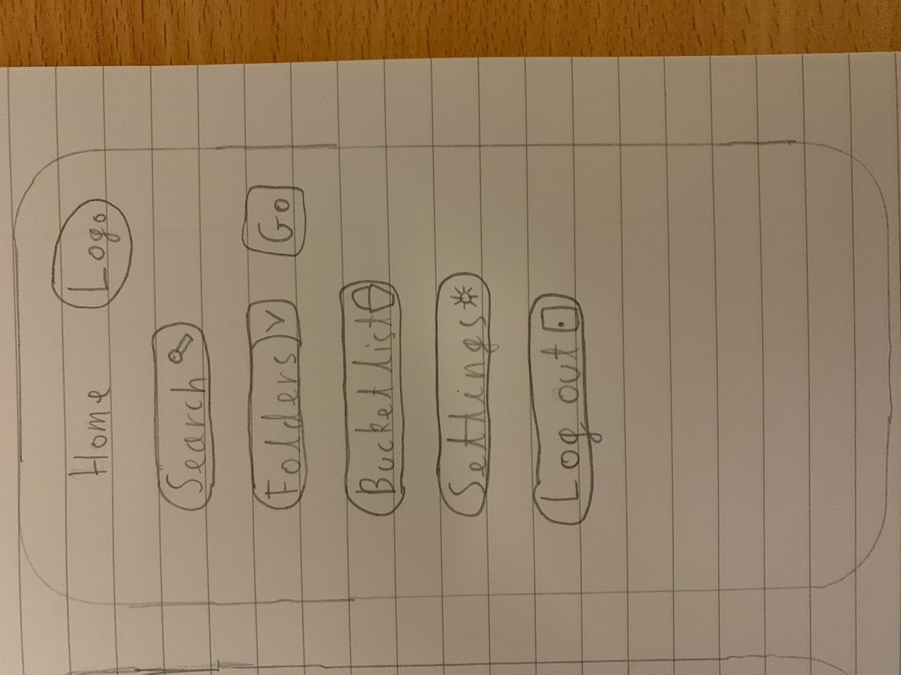

1. Screen title

Figure – Homepage Screen

2. App logo

3. Takes user to Search screen

4. Provides user with a drop down menu of existing folders

5. Takes user to selected folder

6. Takes user to bucket list page

7. Takes user to settings page

8. Logs user out

**Search**

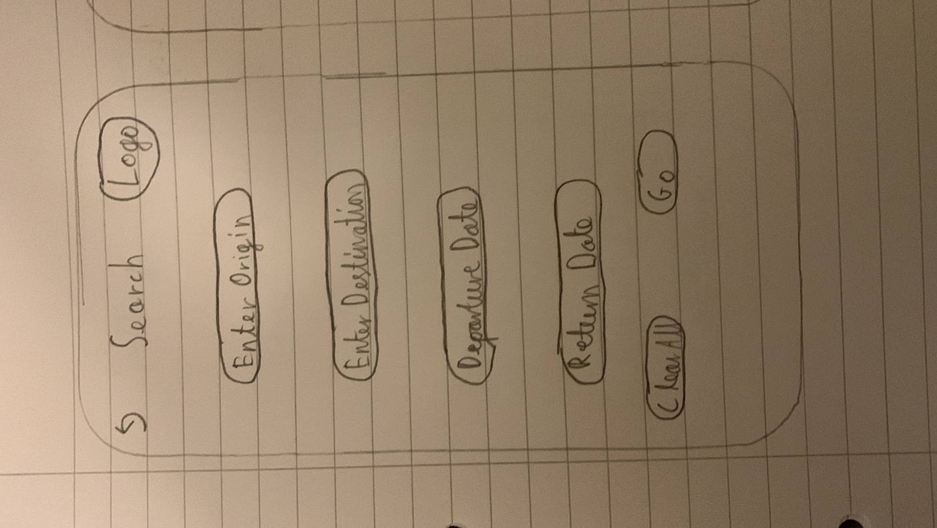

1. Takes user to homepage

2. Screen title

3. App logo

4. Enter origin airport

5. Enter destination airport

6. Enter departure date

7. Enter return date

8. Clears all inputted data (4,5,6,7)

9. Begins search, calling the API with the given parameters (4,5,6,7)

The user will be required to enter 4 parameters, departing date, return date, departure airport, arrival airport

For example, 5th May 2022, 12th May, London Stansted, Istanbul Sabiha Gokcen

Once these are entered, the API will return the flights for these dates, from lowest to highest price.

Figure - Search Page

**Settings**

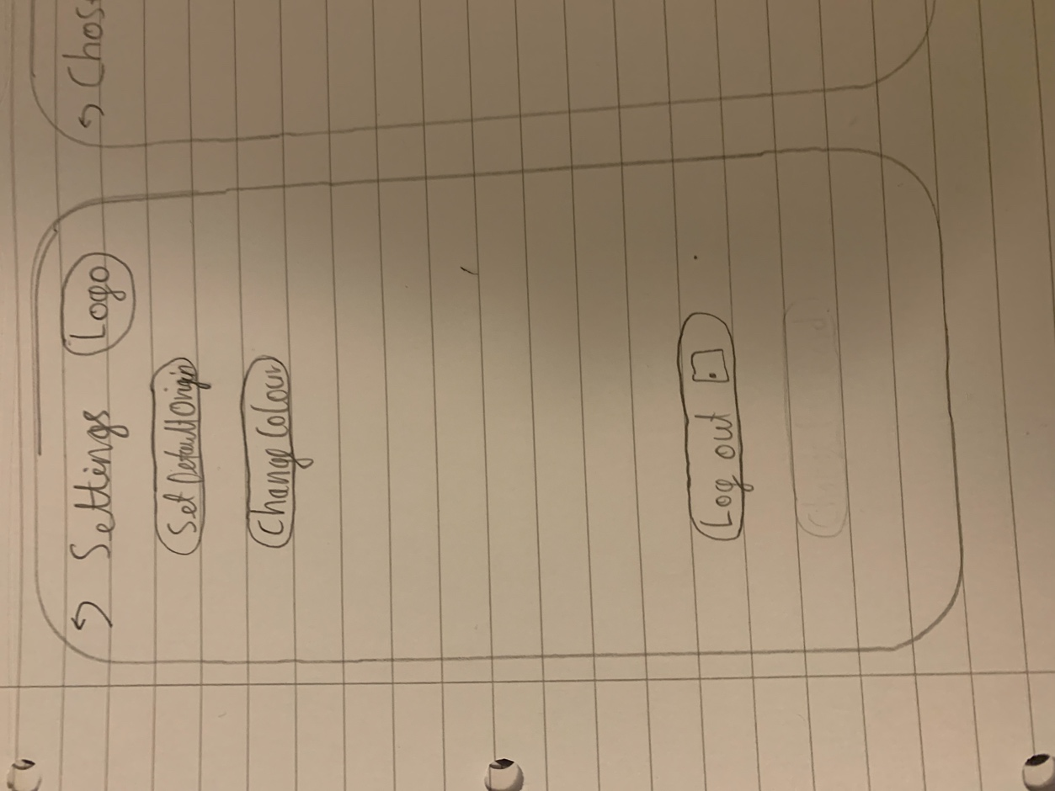

1. Takes user back to homepage

2. Screen title

3. App logo

4. Allows user to set a new default origin destination

5. Drops down with a list of colours, from which the user can select a theme for the app

6. Logs user out

Figure - Settings Screen

**Chosen Folder**

1. Takes user back to the homepage screen

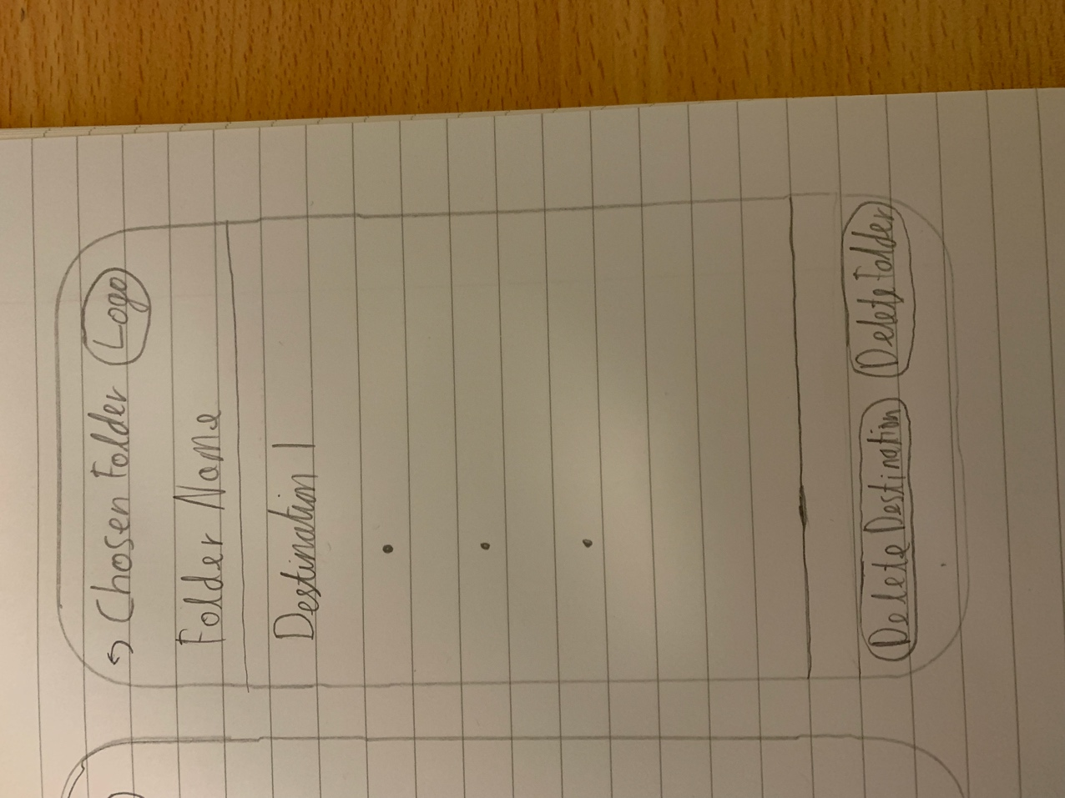

2. Screen title

3. App logo

4. Folder name (e.g. beach holidays)

5. First destination

6. Other results

7. Deletes a destination of the user’s choosing

8. Deletes the entire folder (after a pop up warning message is answered) and returns to the homepage

The middle section (5,6) is scrollable

If a destination is clicked on, it will open the results screen with the exact same parameters as when the search was saved

Figure - Chosen Folder Screen

**Bucket List**

1. Takes user back to the homepage

Figure - Bucket List Screen

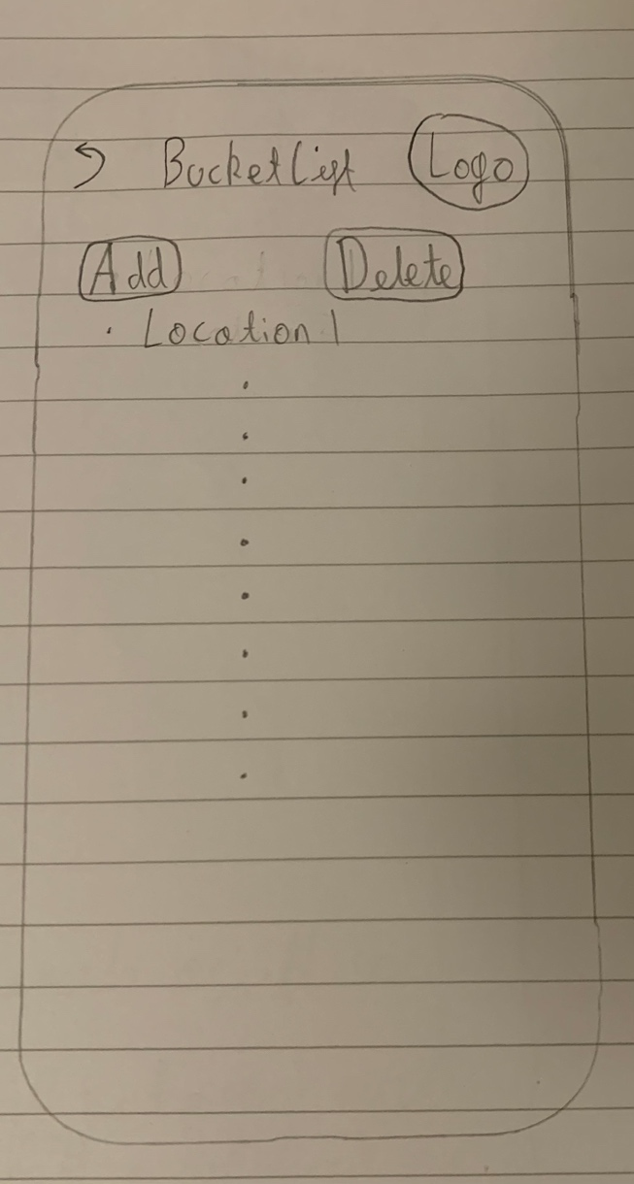

2. Screen title

3. App logo

4. Allows user to select which destination to add

5. Allows user to select which destination to delete

6. First location

7. Other locations (same format as 6)

**Results**

Figure 8 - Results Screen

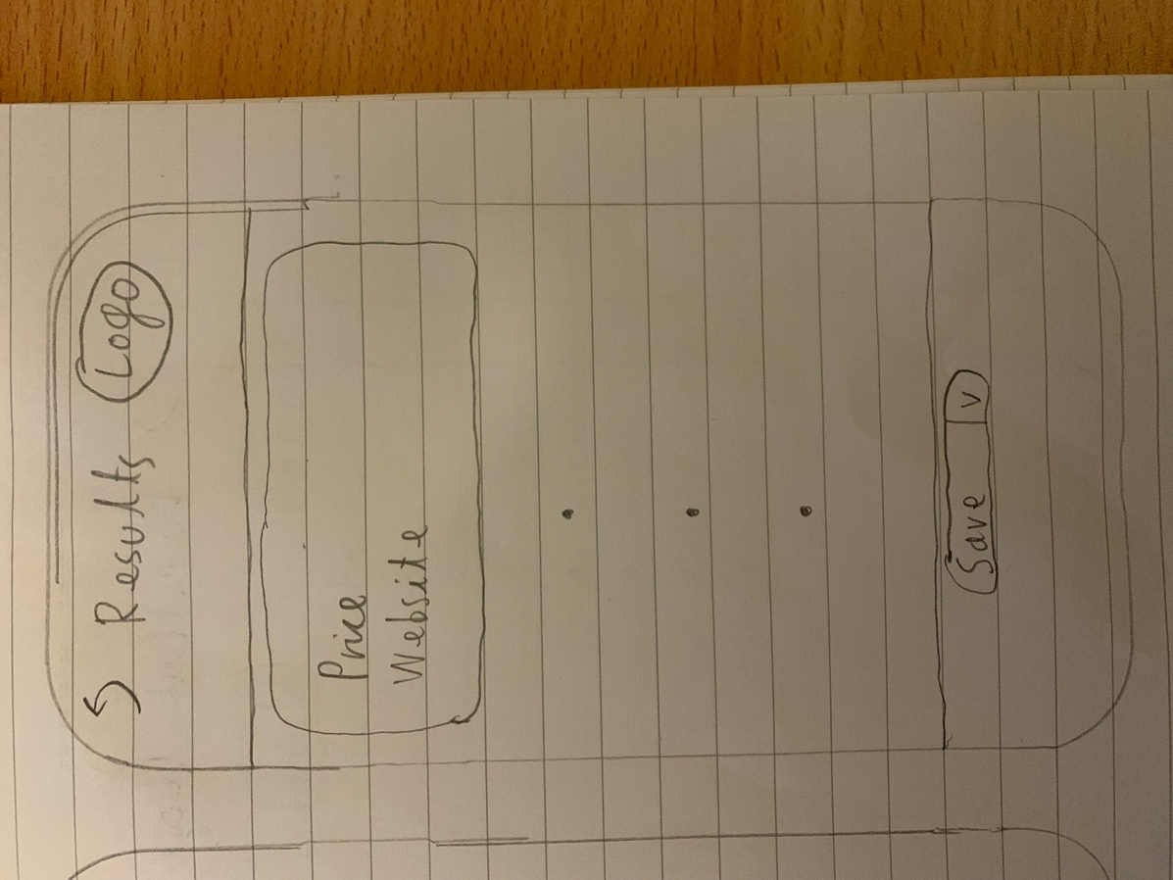

1. Takes user back to their search with all inputs still intact

2. Screen title

3. App logo

4. Cheapest price

5. Website of airline providing the price

6. Other results

7. Select the folder to save the parameters to (or create and name a new folder)

The middle section (4,5,6) is scrollable